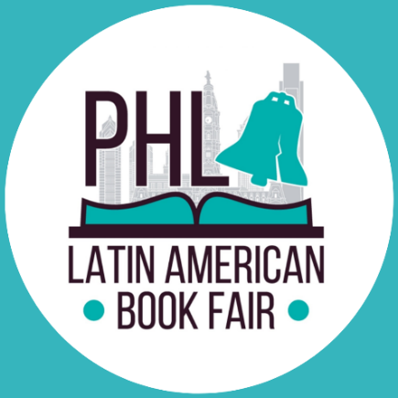

Sponsor Company Name: _____________________________________________

Address: _________________________________________________________________
City: __________________________ State: _________________ Zip Code: ___________
Phone: ____________________________ Website: _______________________________
Event Contact: _____________________________________________________________
Contact Phone: ________________________ Contact email: ________________________

□ $3,500 Title Sponsor - Exclusive Presenting Sponsor
□ $1000 – Julio Cortazar
□ $500 - Gabriel García Márquez
□ $350 - Isabel Allende

Please make checks or money orders payable to: Accion Colombia
Memo line: Your sponsor level / LABF 2022
Mail to: Latin American Book Fair - Leity Rodriguez
4636 N 5th Street Philadelphia, PA 19140

Online payments by Venmo: https://account.venmo.com/u/accioncolombia @accioncolombia

Client Signature: _________________________

Date: ________________

Payment due with signed contract

Please complete the registration form and email it to philaferiadellibro@gmail.com

If your organization’s logo is to be included in the promotional materials, please send a PNG electronic file to philaferiadellibro@gmail.com. If you do not have an electronic file of your logo, please contact Arianne Bracho at (267) 904-1086.

